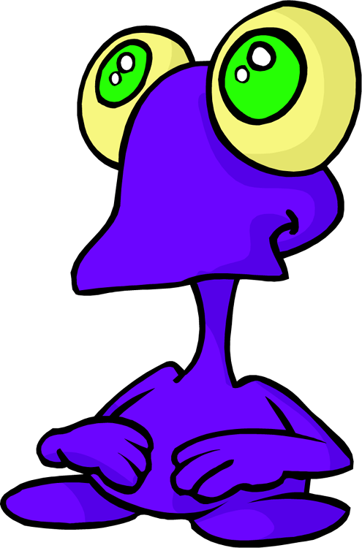
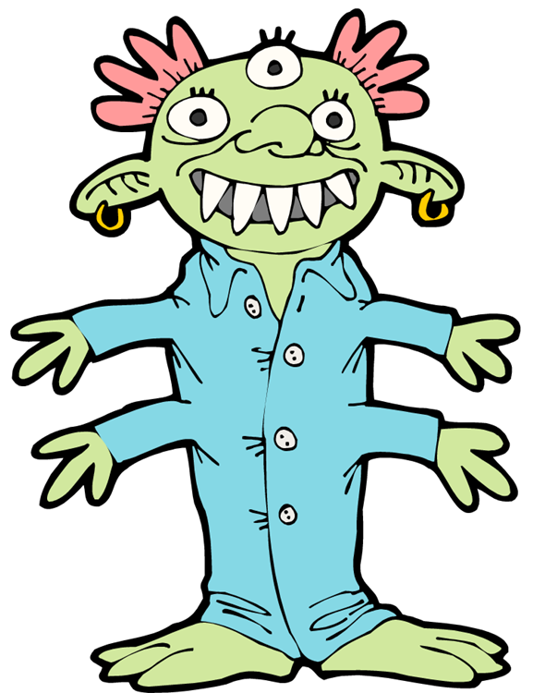
Determining the Traits of a “Mystery Organism”
Through Protein Synthesis

Introduction:
Genes determine what characteristics an organism will have. Genes are segments of DNA molecules that are the instructions for building the proteins of the cell. The sequence of nucleotides in DNA determines the sequence of amino acids in the proteins. In a process called transcription, which takes place in the nucleus of the cell, messenger RNA (mRNA) is made from DNA and carries the instructions for how to make certain proteins. These instructions must be taken to the ribosomes where proteins are made. mRNA carries the instructions from the nucleus to the ribosomes. Once at the ribosome, transfer RNA (tRNA) reads the message, gathers the necessary amino acids, and brings them to the ribosome. The amino acids are lined up, and connected together by peptide bonds to form a protein. This process is known as translation.

In this lab, you will be creating a “mystery organism.” You must determine which proteins must be made to produce your mystery organism. You will be simulating the process of protein synthesis to determine the traits this organism will inherit. Your mystery organism belongs to the Animal Kingdom. It is made up of 6 different genes (A, B, C, D, E, and F). Each of these genes is responsible for a certain trait.

Purpose:
1. To see how the genes on a chromosome determine the characteristics of an organism.
2. To simulate transcription and translation from a DNA template.

Materials: Colored Pencils Paper

Safety Precautions: None

Procedure:

1. Look at the boxes in the data table. You have been given the DNA sequence of 6 different genes that compose a mystery organism. From the DNA sequence given, determine the mRNA codons, the tRNA anticodons, the amino acid sequence, and the trait (protein) made by linking those amino acids.

2. To determine what traits your mystery animal has, fill in the boxes in the data table.

3. To determine the amino acid sequence, refer to the list below. This list contains all codons and their amino acid sequence.

There are 20 different amino acids. A combination of many different amino acids composes different types of proteins. One amino acid is called for by one codon. A codon is a sequence of three nitrogen bases. There are 64 possible combinations of bases (codons), but only 20 amino acids. Several codons may be used to call for the same amino acid.

Copyright © Science Stuff
Amino Acid | Codons for this Amino Acids
Alanine | GCA, GCC, GCG, GCU
Arginine | AGA, AGG, CGA, CGC, CGG, CGU
Asparagine | AAC, AAU
Aspartic Acid | GAC, GAU
Cysteine | UGC, UGU
Glutamic Acid | GAA, GAG
Glutamine | CAA, CAG
Glycine | GGA, GGC, GGG, GGU
Histidine | CAC, CAU
Isoleucine | AUA, AUC, AUU
Leucine | UUA, UUG, CUA, CUC, CUG, CUU
Lysine | AAA, AAG
Methionine - Start | AUG
Phenylalanine | UUC, UUU
Proline | CCA, CCC, CCG, CCU
Serine | AGC, AGU, UCA, UCC, UCG, UCU
Threonine | ACA, ACC, ACG, ACU
Tryptophan | UGG
Tyrosine | UAC, UAU
Valine | GUA, GUC, GUG, GUU
Stop Codons | UAA, UAG, UGA

4. To determine what traits are present in your mystery organism, refer to the table below. Use the amino acid sequences from your data table to determine what characteristic is being called for.

AMINO ACID SEQUENCE | TRAIT
Alanine – Histidine – Lysine | Walks on four legs
Proline – Serine – Phenylalanine – Glycine | Freckles
Tryptophan – Proline – Isoleucine | Walks upright on two legs
Serine – Tryptophan – Lysine | Small purple ears
Cysteine – Alanine | Blue hair, very hairy
Arginine – Histidine – Threonine | Yellow eyes
Histidine – Valine | Very little red hair
Alanine – Glycine – Proline – Serine | No Freckles
Serine – Lysine | Short orange nose
Lysine – Leucine | Long red nose
Tyrosine – Isoleucine – Aspartic Acid | Blue eyes
Proline – Alanine – Alanine | Green elephant ears
Copyright © Science Stuff

Copyright © 2014 Amy Brown (aka Science Stuff)

Data Table:

GENE A | GENE B | GENE C
DNA: ACC GGT TAT | DNA: ACG CGA | DNA: TTT AAC
mRNA: | mRNA: | mRNA:
tRNA: | tRNA: | tRNA:
Amino  Acid  Sequence: | Amino  Acid  Sequence: | Amino  Acid  Sequence:
Trait:

GENE D | GENE E | GENE F
DNA: GGA CGC CGA | DNA: GGG AGG AAA CCC | DNA: GCT GTG TGC
mRNA: | mRNA: | mRNA:
tRNA: | tRNA: | tRNA:
Amino  Acid  Sequence: | Amino  Acid  Sequence: | Amino  Acid  Sequence:
Trait:

OBSERVATION QUESTIONS:

1. Distinguish between transcription and translation.
2. Where does transcription take place? Where does translation take place?
3. How does the ribosome know which proteins to make and how to make them?
4. List the steps in protein synthesis.
5. What is the importance of the “start” and “stop” codons?
6. List 5 different kinds of proteins that might be made by the ribosomes?
7. Distinguish between a codon and an anticodon.
8. Random mutations may occur that cause a change in the order of nitrogen bases in a codon. One type of mutation involves the substitution of one of the nitrogen bases in a codon. Explain the effect of a substitution of one of the bases in a codon.
9. What would be the effect of an addition or a deletion of one of the bases in a codon?
10. Using colored pencils, draw your mystery organism.

Copyright © Science Stuff
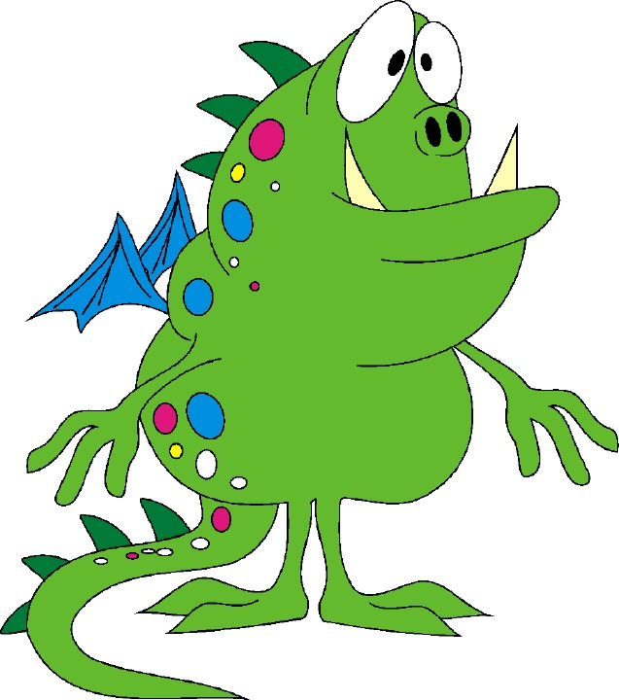
Name __________________________

Determining the Traits of a “Mystery Organism”
Through Protein Synthesis
Student Data Pages
Data Table:

GENE A | GENE B | GENE C
DNA: ACC GGT TAT | DNA: ACG CGA | DNA: TTT AAC
mRNA: | mRNA: | mRNA:
tRNA: | tRNA: | tRNA:
Amino  Acid  Sequence: | Amino  Acid  Sequence: | Amino  Acid  Sequence:
Trait:

GENE D | GENE E | GENE F
DNA: GGA CGC CGA | DNA: GGG AGG AAA CCC | DNA: GCT GTG TGC
mRNA: | mRNA: | mRNA:
tRNA: | tRNA: | tRNA:
Amino  Acid  Sequence: | Amino  Acid  Sequence: | Amino  Acid  Sequence:
Trait:

OBSERVATION QUESTIONS:

1. Distinguish between transcription and translation.

2. Where does transcription take place? Where does translation take place?

3. How does the ribosome know which proteins to make and how to make them?
4. List the steps in protein synthesis.

5. What is the importance of the “start” and “stop” codons?

6. List 5 different kinds of proteins that might be made by the ribosomes?

7. Distinguish between a codon and an anticodon.

8. Random mutations may occur that cause a change in the order of nitrogen bases in a codon. One type of mutation involves the substitution of one of the nitrogen bases in a codon. Explain the effect of a substitution of one of the bases in a codon.

9. What would be the effect of an addition or a deletion of one of the bases in a codon?

10. Using colored pencils, draw your mystery organism.

Copyright © Science Stuff
Teacher Preparation

Pre-Lab Discussion:
Students should be familiar with the concepts of DNA, RNA, and protein synthesis prior to the lab. Students should know the following terms: replication, transcription, translation, codon, anticodon, mRNA, tRNA, and amino acids. Students should know the nitrogen bases and know which bases always pair together.

Data Table Answers:

GENE A | GENE B | GENE C
DNA: ACC GGT TAT | DNA: ACG CGA | DNA: TTT AAC
mRNA: UGG CCA AUA | mRNA: UGC GCU | mRNA: AAA UUG
tRNA: ACC GGU UAU | tRNA: ACG CGA | tRNA: UUU AAC
Amino Acid Sequence:  Tryptophan, Proline,  Isoleucine | Amino Acid Sequence:  Cysteine, Alanine | Amino Acid Sequence:  Lysine, Leucine
Trait: Walks upright on 2 legs | Blue hair; very hairy | Long red nose

GENE D | GENE E | GENE F
DNA: GGA CGC CGA | DNA: GGG AGG AAA CCC | DNA: GCT GTG TGC
mRNA: CCU GCG GCU | mRNA: CCC UCC UUU GGG | mRNA: CGA CAC ACG
tRNA: GGA CGC CGA | tRNA: GGG AGG AAA CCC | tRNA: GCU GUG UGC
Amino Acid Sequence:  Proline, Alanine, Alanine | Amino Acid Sequence:  Proline, Serine, Phenylalanine, Glycine | Amino Acid Sequence:  Arginine, Histidine, Threonine
Trait: Green elephant ears | Freckles | Yellow Eyes

Answers to Observation Questions:
1. Transcription is the process where RNA is made from DNA. The information of a small segment of DNA (a gene’s worth) is copied to form a complimentary strand of RNA.

Translation is the process in which the information contained in RNA is used to direct the sequence of amino acids during protein synthesis.

2. Transcription takes place in the nucleus. mRNA is transcribed from a DNA template. Protein synthesis (translation) takes place on the ribosomes. Ribosomes are found free in the cytoplasm or attached along the endoplasmic reticulum.

3. The ribosome and tRNA uses the information sent in the form of mRNA to know which proteins to make and which amino acids are needed to make them.

4. Complimentary RNA is transcribed from the DNA in the nucleus. This mRNA leaves the nucleus and travels to the ribosomes. tRNA gathers the amino acids necessary and brings them to the ribosomes where they are attached by peptide bonds.
5. The start codon is always AUG. This tells the ribosome where the protein building instructions begin. The stop codons tell the ribosome where the instructions end.

6. Student answers will vary. Possible answers might be: enzymes, hormones, muscles, antibodies, hemoglobin, bones, membrane proteins, transport proteins, storage proteins such as those found inside the eggs of birds and reptiles, or inside seeds, buffers, clotting factors.

7. A codon is a sequence of three nitrogenous bases used to code for one amino acid. An anticodon is a region of tRNA consisting of three bases complimentary to the codon of mRNA.

8. A substitution may or may not have an effect on the protein that is being made. If the substitution is made in the 3rd position, it is likely that it will still code foe the same amino acid. A substitution in the 1st or 2nd position will probably call for a different amino acid.

9. An addition or a deletion of one base would throw off the entire sequence. An addition or deletion at the beginning of the sequence would have a much greater effect that if it occurred near the end of the sequence.

Post – Lab Follow Up:

Here are some additional ideas.

1. Have your students create two additional traits for their “mystery” organism. They should give the DNA sequence, mRNA codons, tRNA anticodons, and resulting amino acid sequence.

2. Research and write a report on the classic studies of DNA. Include the work of Watson, Crick, Meselson and Stahl.

3. Have students construct a model of DNA.

Created by Amy Brown – Science Stuff
Copyright © 2014 Amy Brown (aka Science Stuff)
All rights reserved by author.
This document is for your classroom use only.
This document may not be electronically distributed or posted to a web site.
http://www.teacherspayteachers.com/Store/Science-Stuff

